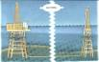

ELYXXON ENGINEERING AND CONSTRUCTION LIMITED

KM 15 INT’L AIRPORT ROAD, RUMUODOMAYA,
PORT HARCOURT, NIGERIA.

Tel: 084-798267, 084-786193,
0802-312-5057, 0805-487-3093. 0803-573-1483
Fax: 084-231719
E-mail: elyxxon@yahoo.com, info@elyxxon.com.
Website: www.elyxxon.com

SMOKELESS FLARE SYSTEM

WORKING MECHANISM OF THE ELYXXON SMOKELESS FLARING SYSTEM

The natural gas with the entrained liquid crude oil for the flow-station (surge vessel) enters the nozzle separation unit at the flow-station discharge pressure. The operation unit works on the principle of convergent –divergent (anti-delaval) mechanism, in separating the gas from the liquid phase. Hence, the gas-oil dual phase (i.e. natural gas and entrained crude oil) flowing into the nozzle unit, experiences a sudden expansion and consequent separation of the two phases.

The lighter component (natural gas) flows on the top level exits through the nozzle tubes into the flare stack while the heavier component (crude oil) drains through the drain tube into a remotely located crude oil extraction pump.

Depending on the client’s choice, the drained crude oil will pumped back to the flow-station, otherwise, it will pumped directly to a smokeless liquid burner located the flare tip through a set of safely confined, and juxtaposed isobaric combustion nozzle. The material of construction for the liquid line, and its combustion system are well chosen to be able withstand the high temperatures associated with the flare tip operation.

The liquid/crude oil extraction processes, together with its smokeless combustion system so described, are the subjects of patent application.

The liquid and the gaseous operate simultaneously in order to enhance combustion efficiency of the flare. Beside, the following processes, takes place when the flare is in operation;

- The gas separator unit throttles the gaseous volume through a distribution of capillary tubes, into the flare stack,

- As it is throttled, the pressure energy of the throttled gas is thereby converted into kinetic energy,

- This energy conversion phenomena results in high gas exit velocity (through the nozzle), with a corresponding pressure drop to atmospheric level,

- As a result of the high gas exit velocity, atmospheric oxygen is aspirated into the flare stack via a conical bell-mouth,

- This flare technology features special devices, located at tandem inside the flare stack, which ensures proper mixing of the aspirated atmospheric oxygen with the in-flowing natural gas without compromising the hydraulic integrity of the flow system.

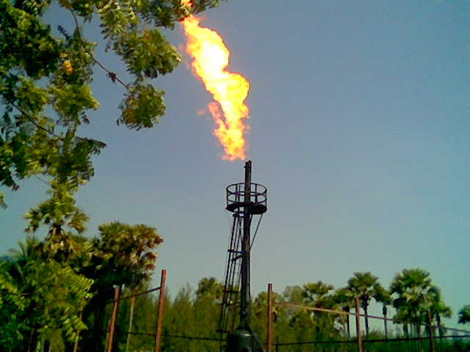
GAS STACK

- Once ignited, the property mixed cloud of air and natural gas (discharging from the flare tip) will burn, and continuously give rise to smokeless flame.

- Flame-front stabilization (i.e. sustained combustion at the flare tip) is achieved by means of a conventional flame stabilizer installed at the tip of the flare.

- The recovery / extraction of entrained crude oil is carried out via portable skid-mounted extraction pumps which are activated and controlled by on-line switches and/or sensors installed on the return line.

- The mixture of the fine liquid particles and the properly blended air/natural gas charge is finally ignited by a remote ignition system (Elyxxon Ignition Torch), located on the flare pilot line, at the flare tip.

- Flare Ignition system (Ignition Torch) comes with a digital ultraviolet flame sensor, which re-ignites the flare if it is extinguished.

- In this smokeless flare technology, the liquid combustion (atomization) does not depend on the pressure energy of the flare gas, and therefore liquid combustion rate is not impeded by external factors e.g. low gas pressure as experienced in conventional atomizers. Turn-down period has no effect on the smokeless liquid burner, since it is not flare gas pressure or volume dependent.

- This smokeless gas flaring system does not feature any conventional atomizer and /or bluff body.

ELYXXON SMOKELESS FLARE FEATURES THE FOLLOWING:

- High liquid and VOCS (volatile organic compounds) combustion rate,

- Highly efficient and un-impeded liquid carry-over combustion even during ‘Turn-down’ or when flare gas pressure is low.

- Minimum noise emission,

- Optional crude oil recovery system,

- High heat resistant pilot line (stainless steel 316L).

- Highly economical, with extremely low running cost,

- Variety of standardized sizes,

- The equipment can be tailored to meet clients specifications,

- Remote ignition system available,

- Minimal pressure drop across the nozzle, and hence noiseless operation,

- Low cost of procurement,

- Flare operates at atmospheric pressure,

- 15 months warranty period,

- Low cost of procurement,

- Automatic Flare Re-ignition (if flare is extinguished).

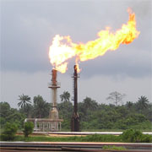

ELYXXON STANDARD FLARE SIZES AND CHARACTERISTICS:

STACK  DIAMETER  (INCHES) | 16 | 20 | 24 | 30
LENGTH  (MM) | 12, 000 | 12, 000 | 12, 500 | 12, 500
LIQUID  BURNER  (BARR  PER HOUR) | 10. 5 | 12. 6 | 14. 4 | 18. 7
NOISE  EMISSION  LEVEL  (DECIBEL) | 70 | 67 | 65 | 65
RINGLE  MANN  NUMBER | 1 | 1 | 1 | 1

